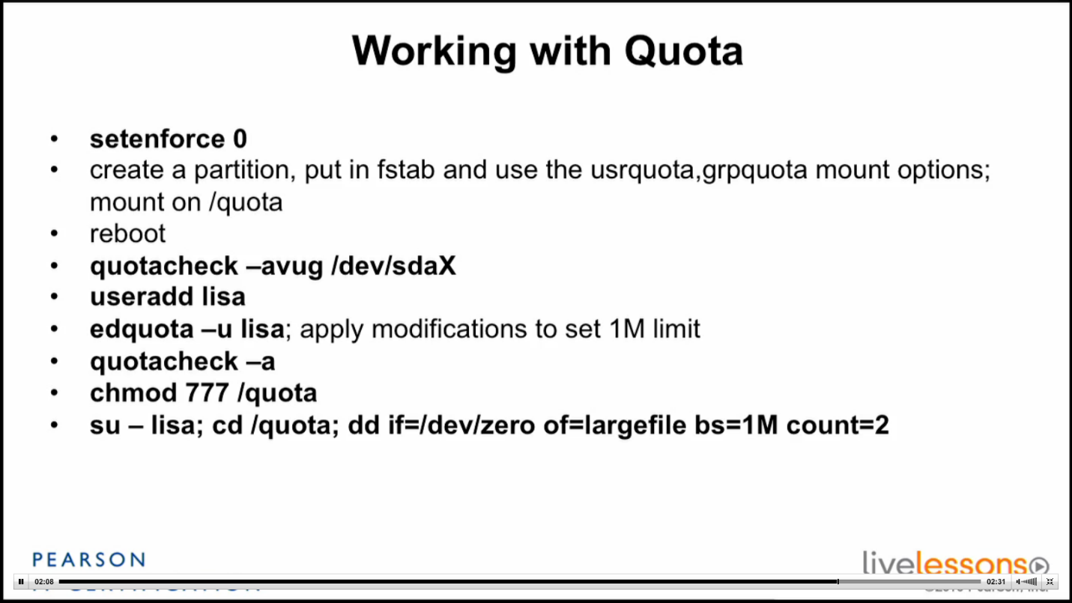

**Configuring Quotas**

To set up quotas, you need to choose a filesystem. It’s not recommended to set quotas on the root (**/**) filesystem, but instead to set quotas on the filesystems that have the most active sets of users and data.

For example, this next exercise was done on a system that has a partition on the device **/dev/sdb5** mounted to the mount point **/data**. An entry in the **/etc/fstab** mounts this partition on system boot. The permissions for the **/data** filesystem allow users who are in the **users** group to create objects in it. There are already files from various users in that directory.

To set up quotas on the **/data** filesystem, do the following:

**1.** Ensure the **/data** partition is mounted by issuing the **mount** command and inspecting the output.

**2.** Edit the **/etc/fstab** file and add **usrquota** and **grpquota**, as shown here, to enable both user and group quotas:

[**Click here to view code image**](ch09_images.html#p278pro01a)

/dev/sdb5  /data  ext3  defaults,usrquota,grpquota  0 0

**3.** Remount the **/data** filesystem with the following command. This enables the quota options you added previously without taking the filesystem offline.

mount –o remount,rw /data

**4.** Check that it has the correct options (shows **usrquota** and **grpquota**) with this command:

[**Click here to view code image**](ch09_images.html#p278pro02a)

# **mount | grep usrquota**  
/dev/sdb5 on /data type ext3 (rw,noexec,nosuid,nodev,usrquota,grpquota)

**5.** Add a normal user to test quotas with the following:

useradd –m quotaboy  
passwd quotaboy

-m: create the user’s home directory

**6.** Now update the **aquota.\*** files

**aquota.user**—The binary file that contains user quota information

**aquota.group**—The binary file that contains group quota information

with the command shown in [Example 9-15](ch09.html#ch09ex15).

**Example 9-15** Updating **aquota.\*** with **quotacheck –avugc**

**-a: check all filesystems**

**-v: verbose**

**-u: check user files**

**-g: check group files**

**-c: create new quota files**

[**Click here to view code image**](ch09_images.html#p09ex15a)

# **quotacheck -avugc**  
quotacheck: Your kernel probably supports journaled quota but you are  
not using it. Consider switching to journaled quota to avoid running  
quotacheck after an unclean shutdown.  
quotacheck: Scanning /dev/sdb5 [/data] done  
quotacheck: Cannot stat old user quota file /data/aquota.user: No such  
file or directory. Usage will not be subtracted.  
quotacheck: Cannot stat old group quota file /data/aquota.group: No  
such file or directory. Usage will not be subtracted.  
quotacheck: Cannot stat old user quota file /data/aquota.user: No such  
file or directory. Usage will not be subtracted.  
quotacheck: Cannot stat old group quota file /data/aquota.group: No  
such file or directory. Usage will not be subtracted.  
quotacheck: Checked 2 directories and 1 files  
quotacheck: Old file not found.  
quotacheck: Old file not found.

The errors you see are just the **quotacheck** command letting you know the quota files don’t contain data yet, but it will update them with the right information. However, options are available for a journaled quota in the mount man page.

After using above command, **aquota.\*** files will be created in /data if they weren’t there before.

**7.** Edit the quota settings for this user with this command:

edquota –u quotaboy

**8.** You see the user’s quota information in **vi**, so you can edit the amounts, like so:

[**Click here to view code image**](ch09_images.html#p279pro01a)

Disk quotas for user quotaboy (uid 1001):  
Filesystem   blocks   soft   hard   inodes   soft     hard  
/dev/sdb5         0      0      0        0      0        0

**9.** Set **quotaboy**’s block quotas to match the following:

[**Click here to view code image**](ch09_images.html#p279pro02a)

Filesystem   blocks   soft   hard   inodes   soft     hard  
/dev/sdb5         0   5000   6000        0      0        0

**6000 = 6MB**

**10.** Save and exit the file;

**quotacheck –a** to reload the quota’s config

[root@localhost usb]# repquota -a

*** Report for user quotas on device /dev/sdb1

Block grace time: 7days; Inode grace time: 7days

Block limits File limits

User used soft hard grace used soft hard grace

----------------------------------------------------------------------

root -- 20 0 0 3 0 0

quotaboy -- 0 5000 6000 1 0 0

[root@localhost usb]# quota quotaboy

Disk quotas for user quotaboy (uid 1008):

Filesystem blocks quota limit grace files quota limit grace

/dev/sdb1 0 5000 6000 1 0 0

Use repquota or quota to confirm that config file was updated

**11.** Sign on as, or use the **su -** command to **become** **quotaboy**:

su – quotaboy

**12.** Create a new file in the **/data** directory as **quotaboy (First, log in as root then chmod R 777 /data)**:

touch /data/file1.quotaboy

**13.** After the user created a file, to check that this file is counted in files column we have to use command **quotacheck –a** .As the **root** user, check to see that **quotaboy** has a quota listed:

[**Click here to view code image**](ch09_images.html#p280pro01a)

# **quota quotaboy**  
Filesystem  blocks   quota   limit  grace   files  quota  limit   grace  
 /dev/sdb5       0    5000    6000              1      0      0

**14.** Turn on the quota system for the **/data** filesystem. Prior to this, the system is tracking quotas but not enforcing them (also the change to quotaboy’s quota is not auto updated, user has to use quotacheck –a, but after using quotaon, there is no need to use quotacheck –a).

quotaon /data

**15.** Log in as **quotaboy** or **su** over to his account:

su – quotaboy

**16.** Run the **quota** command to see what **quotaboy**’s usage is presently:

[**Click here to view code image**](ch09_images.html#p280pro02a)

$ **quota**  
Disk quotas for user quotaboy (uid 1001):  
Filesystem  blocks   quota   limit  grace   files   quota  limit  grace  
 /dev/sdb5       0    5000    6000              0       0      0

**17.** As the **quotaboy** user, copy all the regular files in the **/etc** directory to the **/data** directory:

$ **cp /etc/* /data**

**18.** Run the **quota** command to see how many blocks are used and free:

[**Click here to view code image**](ch09_images.html#p280pro03a)

Disk quotas for user quotaboy (uid 1001):  
Filesystem  blocks   quota   limit   grace  files   quota  limit  grace  
 /dev/sdb5    2524    5000    6000            152       0      0

**19.** Fill up your quota by copying the entire **/etc/** tree to the **/data** directory, observing the multiple errors about the disk quota being exceeded:

cp –r /etc /data

**20.** Be sure to clean up the mess on your test system and try it again until you’re comfortable with configuring quotas.

Your distribution should take care of enabling quotas at boot, which you can test by rebooting and checking for quotas. If not, you need to add **/sbin/quotaon** to your startup scripts.